**Introduction**

As part of activities’ implementation under the project “CSOs Capacity Building to Improve Community Governance and Participate in Issues Based Pro-poor Reform Program”, a five -day Do No Harm and Gender Analysis training was held in Sanniqullie, Nimba County from June 25-29 2018. The opening ceremony of the training was graced by the county Superintendent and the executive director of NARDA. They both expressed gratitude for such initiative. The Superintendent lauded NARDA for conducting such a timely training and requested that some of his staff participate. The training was facilitated by a team of facilitators from the New African Research and Development Agency (NARDA) secretariat, membership and a consultant. The planning process of the training was coordinated by the program department with support from the Administration and Finance departments of NARDA.

**Training Goal and Objective:**

The goal of the training was to strengthen the skills of member NGOs of NARDA in the application of DO No Harm development framework so as increase the promotion of peace in the work they do with communities in Liberia. The principal objectives were to create awareness on the Concept of Do No Harm; and to facilitate county handing head meeting with the county superintendent office in Nimba County.

**Training Participants and Venues**

Forty participants attending the training came from the four NARDA Sector Information Groups (Health, Education, Governance and Agriculture), the Five County NGOs Networks from Bassa, Bong, Lofa, Nimba and Sinoe Counties and representatives from the Nimba County Superintendent office. The training participants were brought together in one accommodated venue at the Agriculture Relief Service (ARS) Compound in Sanniquellie City.

**Training Methodology:**

The training sessions were characterized by plenary discussion, presentations, group works, questions and answers, role play, plus other innovative approaches including ice breakers. Participants were given ample time to practice how to carryout community needs assessment, and plan intervention with peace lance in their respective communities. Throughout the training, the facilitators adopted team-based facilitation style and encourage participants to do the same when conducting working in their communities. This allowed them to peer evaluate themselves on the basic qualities of facilitation skills they were exposed to during the training. However, constant follow up is required to monitor and see how they are facilitating the DO No Harm concept, based on skills acquired from the training.

**Training Content**:

Topics discussed during the training included the overview of the NARDA’s intervention and the concept of the Do No Harm. History of DNH, introduction to DNH, Context Analysis, project Cycle Management, SAVES, River of Life, Project Analysis (design), Implicit Ethnic Massages (impact analysis) and Gender Analysis. Moment of Reflection, Self-Introduction, Recaps, and Evaluation were facilitated through with the the participants. Critical for the workshop was the presentations and discussion sessions on the participants group exercises. The training exposed participants to effective ways of facilitating processes using participatory tools anchored in the DNH Concept that support community peace and development. Participants were also opened to preparing/writing simple projects on the training content.

**Key Learning from the Training:**

The history of DNH helped participants understand the framework as a tool use to make development intervention work good leaving no harm. The well-being of the people in development intervention is the main principle of the DNH emphasized by the facilitators. The four categories of the DNH framework include the research, experience sharing, implementation and mainstreaming stages were clearly explained. Six counts lesson learned were talked about as follow:

* Intervention become part of the context once such intervention enters
* Two set of factors dividers and connectors are in every intervention
* Any intervention interacts with both dividers and connectors
* There are predictable situation that interacts
* The details of an intervention matters
* There are always options

The terms dividers and connectors were explained as issues that lead to conflict in community and issues that help keep peaceful environment. They are not physical being rather they are issues that give rise to tension or promote peace in the community. The Abbreviation SAVES was defined and explained as things that could serve as dividers or connectors:

Systems/Institution,

Attitude and action,

Value and interest,

Experience

Symbol and occasion.

The definition of what a project is was discussed and the stages of project cycle management in the concept of DNH explained. Participants were facilitated through the process of reflecting on their lives pathway. They reflected on the different phases of their lives recognizing their high and low points. The seven key questions answered in project design were careful discussed as WHY- as the perceived need, WHERE- location of the intervention, WHEN- determine date, WHAT-content or resource transfer, WITHWHOM-beneficiaries of the intervention , BY WHOM- staff or persons involved with the intervention and HOW- the process approach or method leading the intervention. Participants were exposed to understanding implicit ethnical massages reference to impact Analysis. Accordingly, three things were highlighted in mathematic formula as **A+B=C**. meaning Action PLUS Behavior have consequences. Action reflects the risk of doing harm and the opportunity that brings about peace. The facilitator explained that thief prevention, market effect, distribution effect, substitution effect and legitimation effect characterize our actions both negatively and positively. Behavior accounts for respect, accountability, fairness and transparency in similar manner. Few gender terms were lengthily discussed in one full session of the training. Participants learned the definition of gender balance, equality, sensitivity and how they play in development intervention. The facilitator explained that gender analysis looks at the constraints that men and women face within a given project and how it is importance to consider concerns unique to the sexes in project planning and implementation. Some practical experiences were shared to help participants understanding of the importance of gender analysis.

**Conclusive outcome**

On the overall, the training provides a unique learning point for all participants to begin discussion as well as take actions that would lead to the promotion of lasting peace in communities they serve. The training provided increased awareness and popularization of the DNH framework and principle in the field of development. The skills of forty plus participants from the NARDA County Network and SIG members and Nimba County Superintendent office were strengthened in engaging community processes from peacebuilding lance. It is convincing to note that the skills gained contributes to participant’s appreciation for NARDA capacity strengthening effort as a result of their experiential engagement through the use of different DNH tools. Moreover, their ability to work as a team was sharpened as the facilitators engaged them with practical exercises and group works. They learned more on how to conduct community needs assessment, and follow up on issues affecting community peace by applying methods and techniques they were exposed to, from the training. On the whole, the training yielded fruitful results as participants shared their new learning with one another. The goal and objectives of the training were achieved as participant’s demonstrated high commitment to apply skills gained during the training process with their respective organization.

**Annexes**

1. List of participants
2. Training photos
3. Group work/Exercise

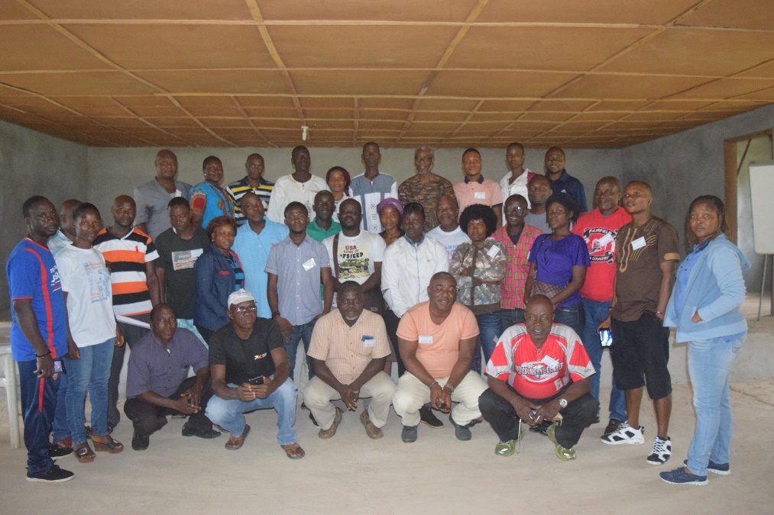

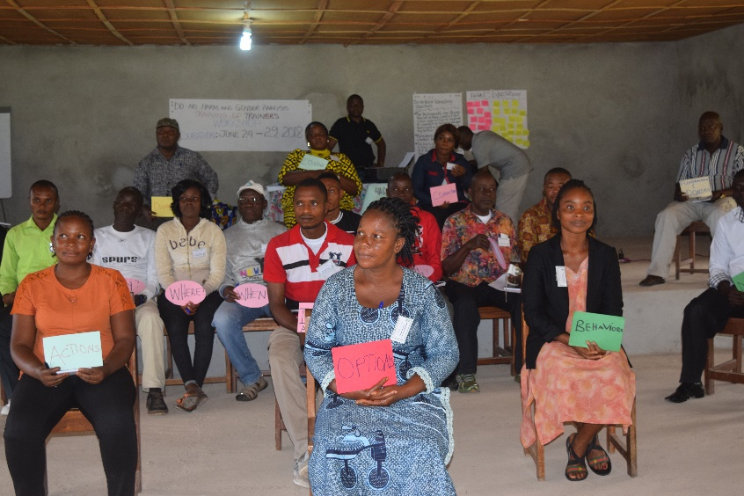

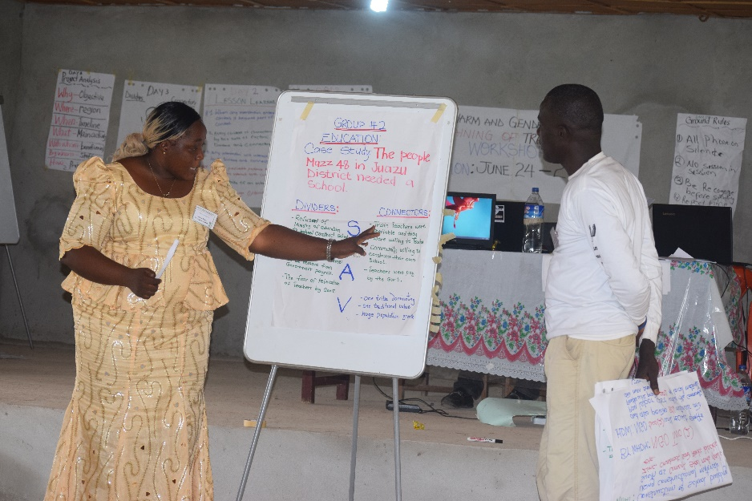

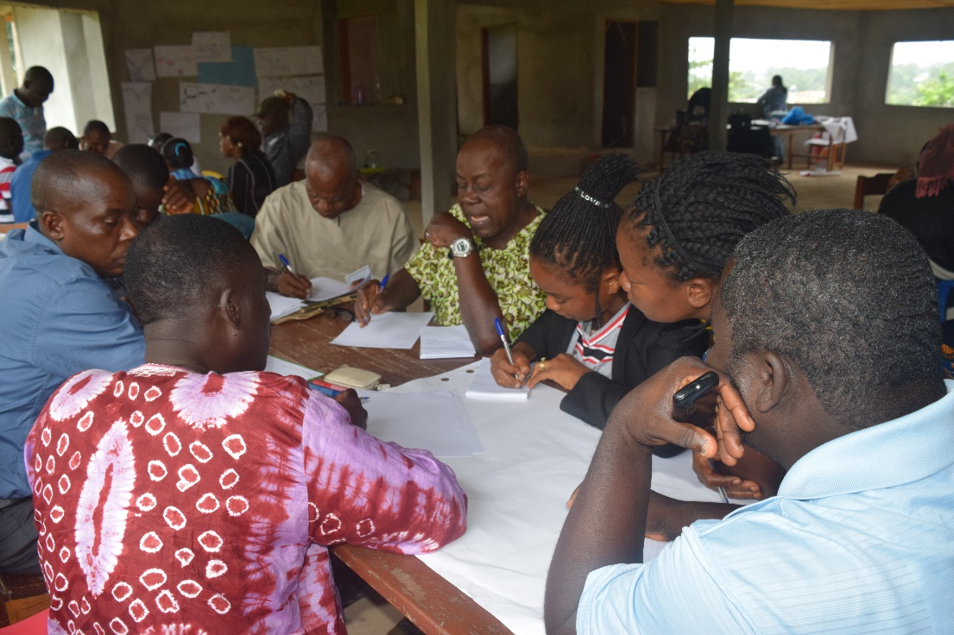

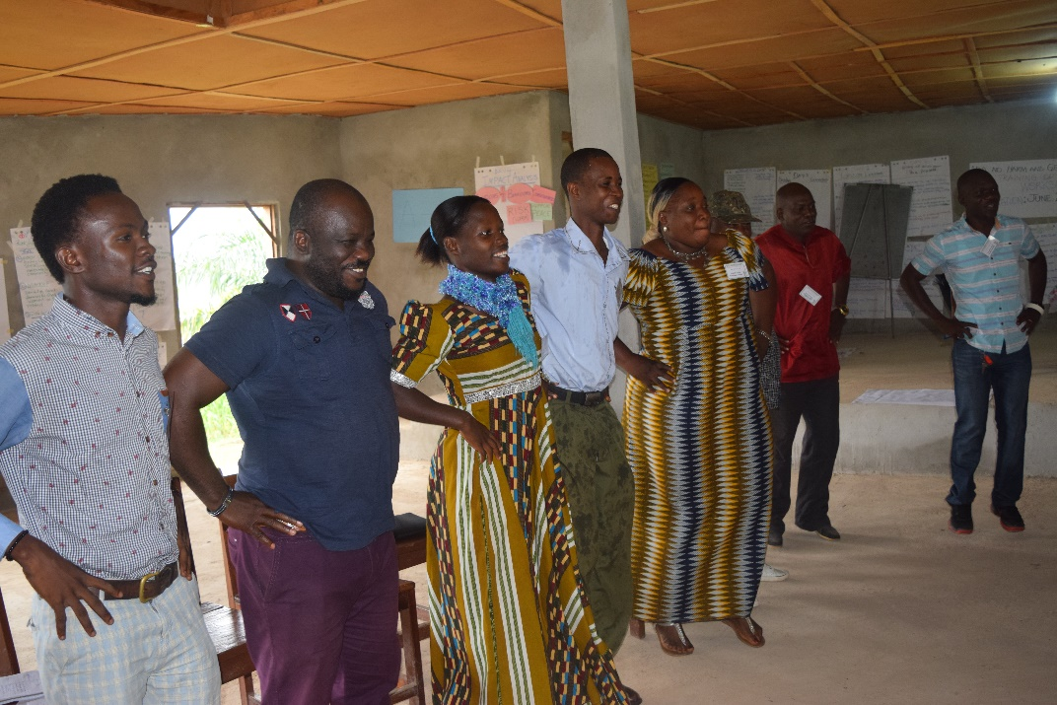

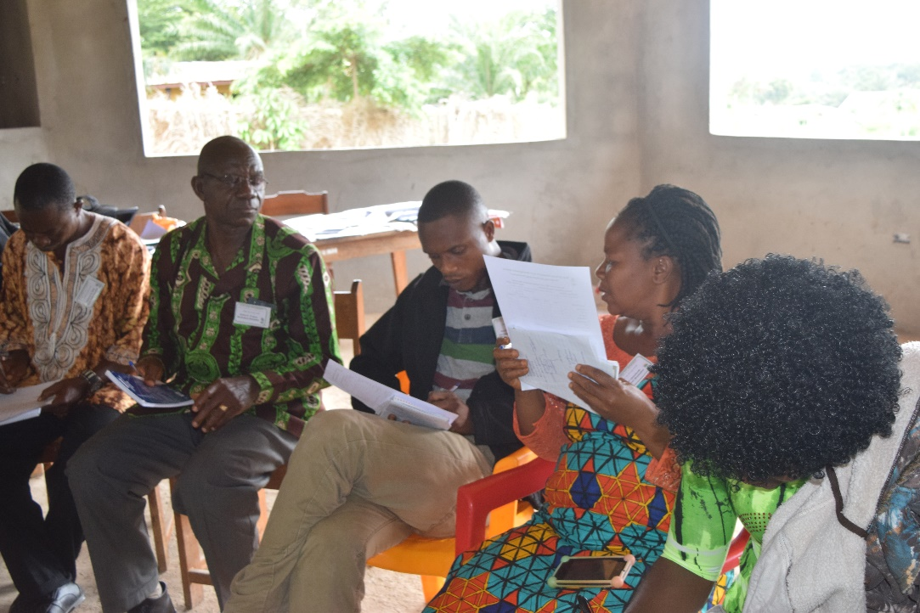

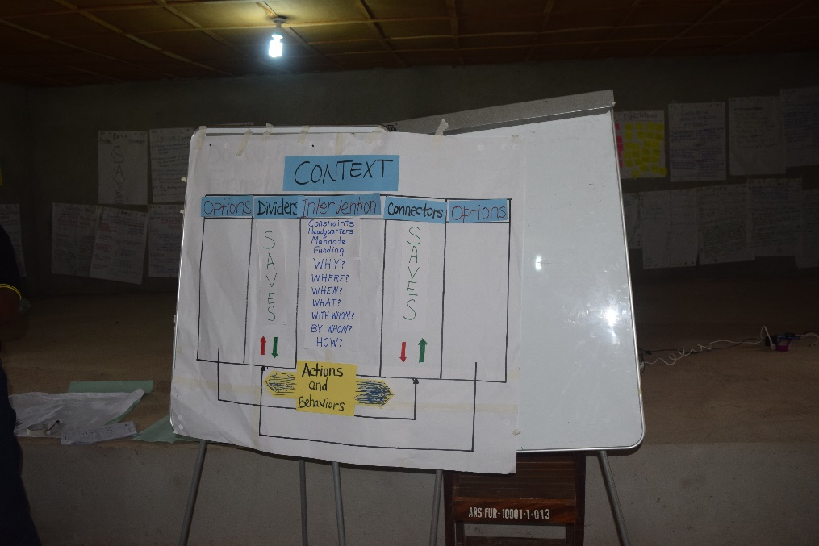

**Participants Listing**  **Date**: June 24-29, 2018

|  |  |  |  |  |  |  |  |
| --- | --- | --- | --- | --- | --- | --- | --- |
| **No** | **Name** | **Gender** | | **Organization** | **Position** | **Tel. Number** | **Email** |
| **M** | **F** |
|  | Welleh Bohlen | X |  | FERD | Focus Person | 0886546977 | childrenlib@gmail.com |
|  | Shelinta D. Botoe |  | X | FERD | Focus Person | 0886525153 | childrenlib@gmail.com |
|  | George Wilson, III | X |  | FLOMO | Training Coordinator | 0775925938 | georgediohwilson@gmail.com |
|  | Alex L. Swaray | X |  | FLOMO | Executive Director | 0770012748 | alexlassanahswaray@gmail.com |
|  | Isaiah B. Wisseh, Sr. | X |  | ROCH | Executive Director | 0886535622 | rochlib1994@gmail.com |
|  | Israel T. Mayue | X |  | ROCH | Program Associate | 0778613246 | rochlib1994@gmail.cpm |
|  | St. John York | X |  | LCC | Director – GGC | 0777129157 | stjohn.york@gmail.com |
|  | Christine O. Dolo |  | X | LCC | Health Coordinator | 0777737808 | christinedolo.06Gmail.com |
|  | David J. Nagbe | X |  | SHIFSD | Asst. Program Off. | 0778436097 | davidjnagbe91@gmail.com |
|  | Emmanuel J. Saygbe | X |  | SHIFSD | Coordinator | 0777815170 | ejsaygbe76@gmail.com |
|  | Curtis Dabieh | X |  | AEL | Food Security Officer | 0886537846 | cdabieh@yahoo.com |
|  | Fetha Y. Kollie |  | X | AEL | HR/Administrator | 0886975342 | fetha_yeahgar@yahoo.com |
|  | Harris B. Zondo | X |  | BassaNet | Supervisor | 0777528308 | sacods2007@gmail.com |
|  | Martin Yuway | X |  | BassaNet | Asst. Administrator | 0770920799 | buccobac@yahoo.com |
|  | Z. Momo Seh | X |  | PPAL | M&E Assistant | 0776375974 | momoseh12@gmail.com |
|  | O’Neill Philips | X |  | AGENDA | Program Officer | 0886800914 | wudukuweh29@yahoo.com |
|  | Luogon P. Lah | X |  | NimbaNet | Chairman | 0777574175 | luogonplah@yahoo.com |
|  | Tongor Quaduah | X |  | NimbaNet | Logistics clerk | 0777172095 | krudfinc@yahoo.com |
|  | Boakai Yarmah | X |  | LofaNet | VP, Administration | 0770242734 | yboakai2015@gmail.com |
|  | Deddeh Kollie |  | X | LofaNet | Chaplain | 0777852141 | sisdeddeh2007@gmail.com |
|  | Nelson Diakpo | X |  | CHAL | County Field Officer | 0880877655 | nelsiondiapo@gmail.com |
|  | Alex Weah | X |  | CHAL | County Field Officer | 0776579383 | alexgaweah@gmail.com |
|  | Jimmy B. Dennis, Jr. | X |  | LOIC | Head Trainer | 0886414589 | jbdennis7@gmail.com |
|  | Rachel Paye |  | X | LOIC | Job Developer | 0886472198 | oicgbarngasatellite@gmail.com |
|  | Aaron Sackie-Fenlah | X |  | BongoNet | Treasurer | 0770237544 | sackiefenlah@gmail.com |
|  | Patricia Mulbah |  | X | BongoNet | Volunteer | 0888601249 |  |
|  | Lawrence K. Bloh | X |  | SinoeNet | Co-Chairman | 0886141971 | lblohkoryee397@gmail.com |
|  | Weedor Smith |  | X | SinoeNet | Member | 0886672730 | smithweedor6@gmail.com |
|  | Darius D. Wehyee | X |  | NimbaNet | Exe. Director | 0886449818 | ears2004@gmail.com |
|  | Betty Gbalah |  | X | NimbaNet | Member | 0770644525 |  |
|  | Gifty K. T. Walee |  | X | NimbaNet | Member | 0775633025 | giftyktwalee@gmail.com |
|  | Frederick D. Dao | X |  | NimbaNet | Reporter | 0776347194 |  |
|  | Michael P. Yarkpah | X |  | County Office | Protocol Officer | 0775211736 | yarkpahmichael@gmail.com |
|  | Amos Gbannah | X |  | County Office | Information Officer | 07700404471 |  |
|  | Marvel G. Bella |  | X | NimbaNet | Member | 0776458722 | marvelgbella@gmail.com |
|  | Michael K.M. Blahpue | X |  | Nimbanet | Member | 0777371368 | mkmblahpue@gmail.com |